**Project Initialization and Planning Phase**

| Date | 21 March 2024 |
| --- | --- |
| Team ID | SWTID1720437635 |
| Project Name | Nutrition App Using Gemini Pro: Your Comprehensive Guide to Healthy Eating and Well-Being. |
| Maximum Marks | 3 Marks |

**Define Problem Statements (Customer Problem Statement Template):**

The Customer Problem Statement template helps you focus on what matters to create experiences people will love. A well-articulated customer problem statement allows you and your team to find the ideal solution for your customers' challenges. Throughout the process, you’ll also be able to empathize with your customers, which helps you better understand how they perceive your product or service.

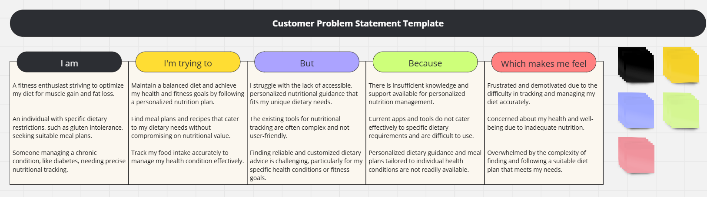

**Reference link:** https://miro.com/app/board/uXjVKxeNX_Q=/?share_link_id=449642332737

|  |  |  |  |  |  |
| --- | --- | --- | --- | --- | --- |
| **Problem**  **Statement (PS)** | **I am**  **(Customer)** | **I’m trying to** | **But** | **Because** | **Which makes me feel** |
| PS-1 | A fitness enthusiast striving to optimize my diet for muscle gain and fat loss | Maintain a balanced diet and achieve my health and fitness goals by following a personalized nutrition plan. | I struggle with the lack of accessible, personalized nutritional guidance that fits my unique dietary needs. | There is insufficient knowledge and support available for personalized nutrition management. | Frustrated and demotivated due to the difficulty in tracking and managing my diet accurately. |
| PS-2 | An individual with specific dietary restrictions, such as gluten intolerance, seeking suitable meal plans. | Find meal plans and recipes that cater to my dietary needs without compromising on nutritional value | The existing tools for nutritional tracking are often complex and not user-friendly. | Current apps and tools do not cater effectively to specific dietary requirements and are difficult to use. | Concerned about my health and well-being due to inadequate nutrition |
| PS-3 | Someone managing a chronic condition, like diabetes, needing precise nutritional tracking. | Track my food intake accurately to manage my health condition effectively. | Finding reliable and customized dietary advice is challenging, particularly for my specific health conditions or fitness goals. | Personalized dietary guidance and meal plans tailored to individual health conditions are not readily available. | Overwhelmed by the complexity of finding and following a suitable diet plan that meets my needs. |